Experiment No.: 8
1.Title: Access and Validate form fields using events; design a gym admission form with live input using html,css,js.
2. Software/Tools Required: VSC,HTML,CSS
3. Theory: This experiment demonstrates form field validation using JavaScript events.
Different events like input, change, and submit are used to check user-entered data.
If the input is invalid, an error message is displayed, while valid input is accepted.
4.Output:
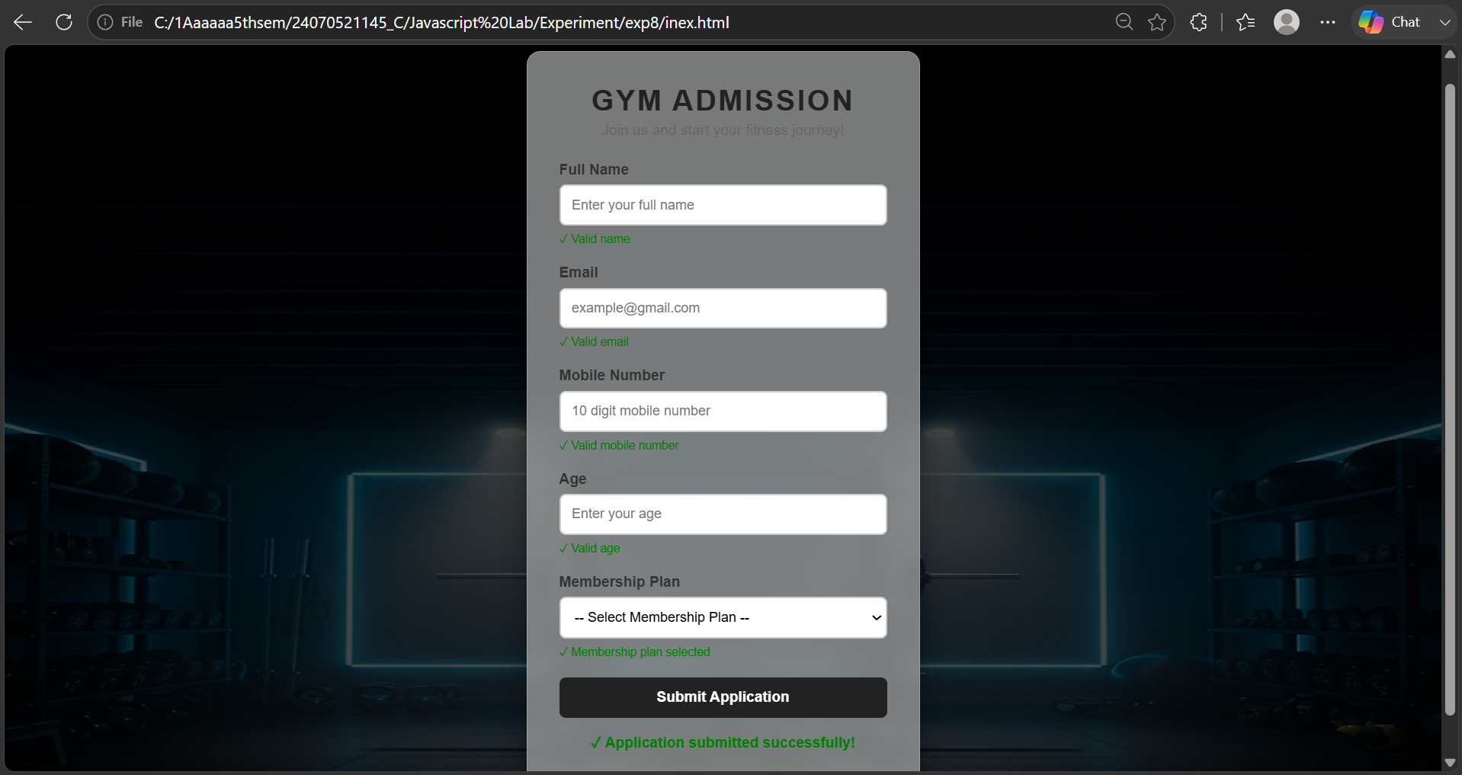
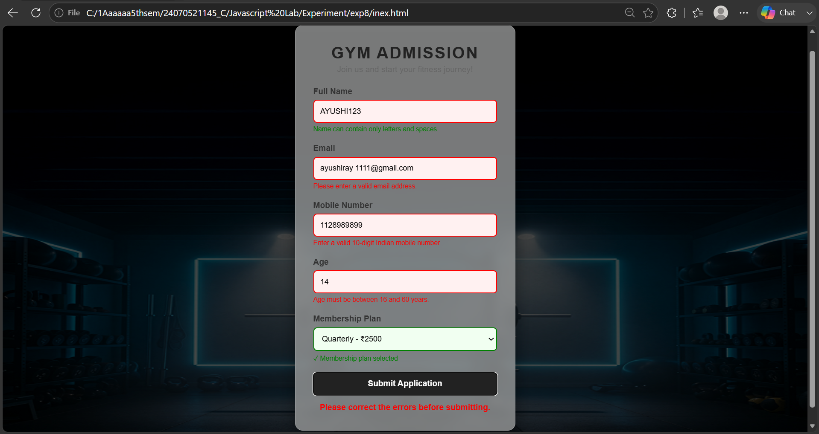
Result: The Gym Admission Form was successfully created using HTML, CSS, and JavaScript.
The form validates user inputs live and displays error messages for invalid entries.
Events such as input, change, and submit were successfully implemented.
Valid details are accepted, while incorrect details are rejected with suitable error messages.

